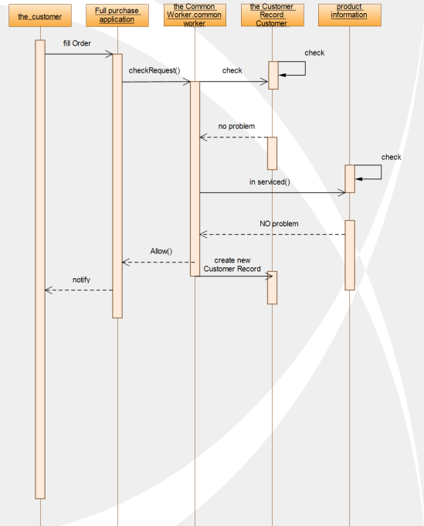

Some customers want to buy out the goods. First, the customer needs to fill out an electronic application form for purchase. The software background administrator is responsible for processing these application forms. The administrator will judge whether the user has credit according to the user's historical rental record, if the conditions are met. Then the request will be allowed, the customer can purchase the permanent right to purchase the full amount. If the background finds that the conditions are not met, the customer's application will be rejected, so the user can not choose the permanent use right purchase option of the product. . When the transaction is successful, the system administrator will add a purchase record instead of a lease record to the user's record.